Application Number | 07/2018/2840/FUL
Address | St James Church Of England School  Slater Lane  Moss Side  Leyland  Lancashire  PR25 1TL
Applicant | Mrs L Taylor-Bell - Headteacher

Agent
Mr Jeff Heskine
12 The Spinney
Lancaster
LA1 4JQ

Development | Formation of Multi Use Games Area on school field to rear and erection of 3m high boundary fencing
Officer Recommendation  Officer Name | Approval with Conditions  Mr Chris Sowerby

Date application valid | 11.05.2018
Target Determination Date | 06.07.2018
Extension of Time | N/A

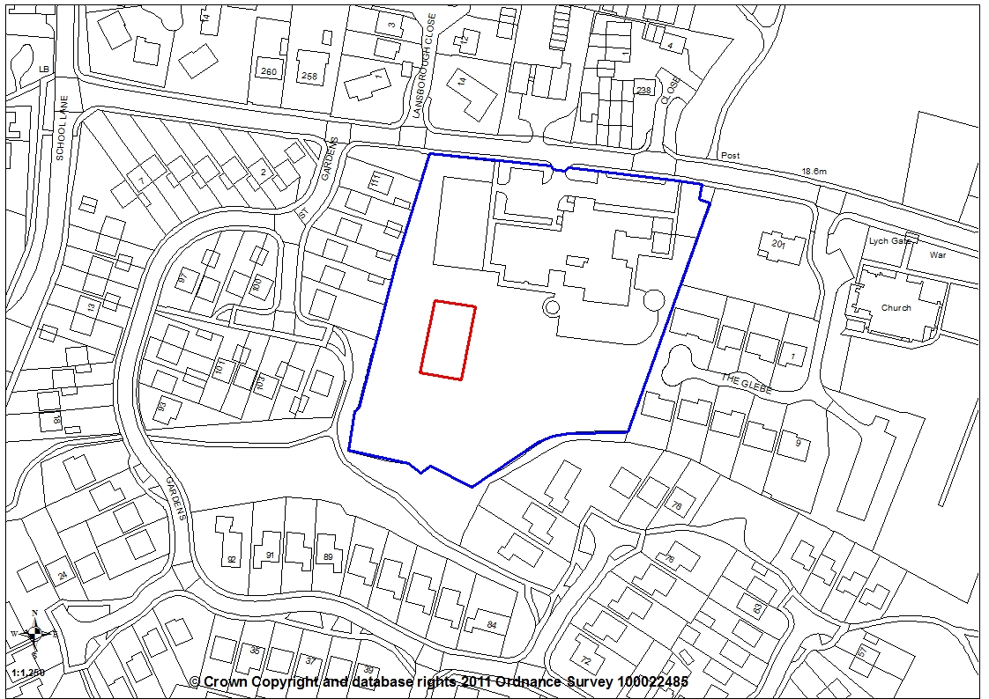
1. INTRODUCTION
1.1 As an Officer of the Planning Department is a Governor at the School to which the application relates the application has been brought before the Planning Committee for determination.

2. REPORT SUMMARY
2.1 The application relates to St. James Church of England School located on the south side of Slater Lane in Leyland. School buildings and areas of hardstanding are generally located to the front of the site with the school playing field towards the rear of the site. The application site is within an area of land designated as Green Infrastructure (Policy G7) in the South Ribble Local Plan.

2.2 The application seeks planning permission for the formation of a multi-use games area enclosed by 3m high fencing. The proposed games area would be surfaced in permeable Tarmacadam and measure 25m (length) x 15m (width). No floodlights or lighting columns are proposed. The agent has stated within supporting information submitted with the planning application that the games area would be for the sole use of the school.

2.3 Policy G7 encourages the ‘multi-use’ of Green Infrastructure spaces for leisure and recreational purposes. As the proposed development does not result in the loss of Green Infrastructure provision but actually would improve the recreational facilities present for pupils the proposed development accords with the requirements of Policy G7.

2.4 Existing buildings would partially screen the site from Slater Lane with only distant views of the games area to be present across the school playground. A minimum distance of 19m would be present from the proposed multi-use games area to the nearest residential property at 107 St James Gardens. Given the area of the school playing field on which the games area is to be sited is already actively used by pupils and the facility would be for the sole use of the school there is considered to be no undue loss of amenity as a result of the use proposal.

2.5 There are no highway safety or ecological implications associated with the proposal.

2.6 The application complies with Policy 17 the Core Strategy together with Policies G7 and G17 of the South Ribble Local Plan. The application is therefore recommended for approval subject to the imposition of conditions.

3. APPLICATION SITE AND SURROUNDING AREA
3.1 The application relates to St. James Church of England School located on the south side of Slater Lane in Leyland. School buildings and areas of hardstanding are generally located to the front of the site with the school playing field towards the rear of the site.

3.2 The school playing field is bounded to the west by residential properties on St. James Gardens and to the east by residential properties on The Glebe. A series of mature trees, which are not subject to a Tree Preservation Order, are present along the rear boundary of the site. The application site is located slightly off-centre (to the west) within the school playing field.

3.3 The application site is within an area of land designated as Green Infrastructure (Policy G7) in the South Ribble Local Plan.

4. SITE HISTORY
4.1 Numerous planning applications have been submitted over the years relating to the main school building. There are however no previous applications relating to development on the school playing pitch.

5. PROPOSAL
5.1 The application seeks planning permission for the formation of a multi-use games area enclosed by 3m high fencing. The proposed games area would be surfaced in permeable Tarmacadam and measure 25m (length) x 15m (width).

5.2 The proposed games area would be set 65m back from the site frontage with a minimum of 19m present to the western site boundary with 107 St James Gardens. A distance of 45m would be present to the rear boundary with a distance of 80m to the eastern boundary.

5.3 No floodlights or lighting columns are proposed.

5.4 The agent has stated within supporting information submitted with the planning application that the games area would be for the sole use of the school.

6. REPRESENTATIONS

6.1 As of the 4th June one letter of representation has been received. The letter offers a neutral opinion of the proposal but seeks confirmation that the games area would only be used by the school and only during normal school hours.

7. CONSULTATION REPLIES

Environmental Health have raised no objections to the proposal subject to the imposition of conditions relating to hours of construction, hours of use, the installation of rubber strips and washers on the fencing and restriction on floodlights. A recommended condition relating to restricting the hours of deliveries does not meet the test for conditions as the scheduling of delivery vehicles is unlikely to be in direct control of the applicant.

Ecology have raised no objections to the proposal confirming that the school playing field is highly likely to be of low ecological value and the absence of any proposed floodlighting means that there should be no ecological issues.

The Local Authority’s Arboriculturist has raised no objections to the development.

8. MATERIAL CONSIDERATIONS

Policy Considerations

8.1 i) NPPF
8.1.1 The NPPF promotes a presumption in favour of sustainable development and supports opportunities for sport and recreation.

8.2 ii) Core Strategy Policy Considerations
8.2.1 Policy 17 of the Core Strategy, which is entitled ‘Design of New Buildings’ but applies more broadly to any form of built development, requires an assessment to be made of the design of new structures to ensure that they are in character with the surroundings and will not adversely affect neighbours.

8.2.2 Policy 24 of the Core Strategy, which is entitled ‘Sport and Recreation’, promotes access to sport and recreation facilities.

8.3 iii) South Ribble Local Plan (2012-2026)
8.3.1 Within the Local Plan the application site is allocated under Policy G7 as Green Infrastructure. Policy G7 encourages the ‘multi-use’ of Green Infrastructure spaces for leisure and recreational purposes. As the proposed development does not result in the loss of Green Infrastructure provision but actually would improve the recreational facilities present for pupils the proposed development accords with the requirements of Policy G7.

8.4 Character and Design
8.4.1 Policy 17 of the Core Strategy and Policy G17 of the Local Plan, sets out design criteria for new development and requires development to be well related to neighbouring buildings and the locality.

8.4.2 Existing buildings would partially screen the site from Slater Lane with only distant views of the games area to be present across the school playground. There are no other public vantage points where the proposed games area and perimeter fencing could be viewed. The visual impact the proposed development would have on the character and appearance of the area is therefore negligible with no external lighting proposed. The proposed development is therefore considered to comply with Policy G17 Criterion a), relating to the character and appearance of the area and Core Strategy Policy 17.

8.5 Relationship To Neighbours
8.5.1 A minimum distance of 19m would be present from the proposed multi-use games area to the nearest residential property at 107 St James Gardens. Given the area of the school playing field on which the games area is to be sited is already actively used by pupils and the facility would be for the sole use of the school there is considered to be no undue loss of amenity as a result of the use proposal. Conditions can be imposed to safeguard amenity including restricting the use solely for the school and the hours that construction of the facility is permitted.

8.6 Highway Issues
8.6.1 As the proposed facility would solely be used in connection with the existing use of the site as a primary school the games area would not be a traffic generator. Consequently the proposed development will not impact on highway safety or highway capacity.

8.7 Tree Issues / Wildlife
8.7.1 The proposed games area would be sited 45m from the rear boundary along which a belt of mature trees are present. The Local Authority’s Arboriculturist has raised no objections to the proposed development which will not have an adverse on any tree.

8.7.2 With the site comprising of mown grass the Council’s Ecology advisors have confirmed that the school playing field is highly likely to be of low ecological value and the absence of any proposed floodlighting means that there should be no ecological issues.

8.8 CONCLUSION
8.8.1 The proposed formation of a multi-use games area enclosed by 3m high fencing at St James Church of England School, by virtue of the distance to Slater Lane and intervening buildings, will not have a detrimental impact on the character and appearance of the area or the amenities of nearby properties. Environmental Health have raised no objections to the proposal subject to the imposition of conditions detailed within this report. There are no highway safety or ecological implications associated with the proposal.

8.8.2 The application complies with Policy 17 the Core Strategy together with Policies G7 and G17 of the South Ribble Local Plan. The application is therefore recommended for approval subject to the imposition of conditions.

RECOMMENDATION:

Approval with Conditions.

RECOMMENDED CONDITIONS:

1. That the development must be begun not later than the expiration of three years beginning with the date of this permission.

REASON: Required to be imposed pursuant to section 91 of the Town and Country Planning Act 1990.

2. No work shall be commenced until satisfactory details of the colour of the permeable tarmacadam surfacing treatment to be used have been submitted to and approved by the Local Planning Authority. The development shall be carried out in accordance with the approved details

REASON: To ensure the satisfactory detailed appearance of the development in accordance with Policy 17 in the Central Lancashire Core Strategy and Policy G17 in the South Ribble Local Plan.

3. The use of the development hereby approved shall be restricted to the hours of 09:00am to 17:00pm Monday to Friday and the premises shall not be used at any time on Saturdays, Sundays or Bank/Public Holidays or School Holidays.

REASON: In the interests of the amenities of adjoining residents and to accord with Policy 17 in the Central Lancashire Core Strategy

4. That the development hereby approved shall not be open for community / public use.

REASON: In the interests of the amenities of adjoining residents and to accord with Policy 17 in the Central Lancashire Core Strategy

5. During the site preparation and construction of the development hereby approved, no machinery shall be operated; no process shall be carried out and no deliveries taken at or dispatched from the site outside the following times:

0800 hrs to 1800 hrs Monday to Friday
0800 hrs to 1300 hrs Saturday

No activities shall take place on Sundays, Bank or Public Holidays.

REASON: To safeguard the living conditions of nearby residents particularly with regard to the effects of noise in accordance with Policy 17 in the Central Lancashire Core Strategy.

6. The fence surrounding the MUGA hereby approved shall be fitted with heavy duty rubber strips and rubber washers between each connection to prevent vibration when struck with balls. The fence and rubber strips/washers shall thereafter be maintained.

REASON: To safeguard the living conditions of nearby residents in accordance with Policy 17 in the Central Lancashire Core Strategy.

7. No external floodlighting or security lights shall be installed without first obtaining written permission from the Local Planning Authority.

REASON: To safeguard the living conditions of nearby residents in accordance with Policy 17 in the Central Lancashire Core Strategy.

8. The development, hereby permitted, shall be carried out in accordance with the submitted approved plans ref 'SJPS/MUGA/JH/1 Rev A' (Proposed Site Plan), 'SJPS/MUGA/JH/2' (Proposed Multi Use Games Area)

REASON: To ensure a satisfactory standard of development in accordance with Policy 17 in the Central Lancashire Core Strategy and Policy G1 of the South Ribble Local Plan (2012-2026).

RELEVANT POLICY

17 Design of New Buildings (Core Strategy Policy)

POLG7 Green Infrastructure Existing Provision

POLG17 Design Criteria for New Development

Note:

